DATA STRUCTURES AND ALGORITHMS
TASK:04
Syed Umaid Gillani(040)
QUESTION:01
Add a New Product at the End

CODE:
#include <iostream>
using namespace std;
struct Node {
string productID;
Node* next;
};
int main() {
Node* head = new Node{"P101", nullptr};
head->next = new Node{"P102", nullptr};
head->next->next = new Node{"P103", nullptr};
head->next->next->next = new Node{"P104", nullptr};
Node* newNode = new Node{"P105", nullptr};
Node* temp = head;
while (temp->next != nullptr) {
temp = temp->next;
}
temp->next = newNode;
temp = head;
while (temp != nullptr) {
cout << temp->productID << " -> ";
temp = temp->next;
}
cout << "None";
return 0;
}
OUTPUT:
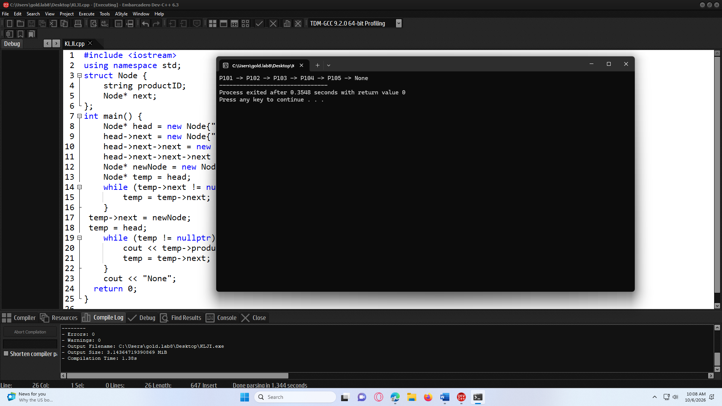

QUESTION:02
Insert a Train Station in the Middle
CODE:
#include <iostream>
using namespace std;
struct Node {
string station;
Node* next;
};

int main() {

Node* head = new Node{"Lahore", nullptr};
head->next = new Node{"Gujranwala", nullptr};
head->next->next = new Node{"Rawalpindi", nullptr};
head->next->next->next = new Node{"Islamabad", nullptr};
Node* newNode = new Node{"Gujrat", nullptr};
Node* temp = head;
while (temp != nullptr && temp->station != "Gujranwala") {
temp = temp->next;
}
if (temp != nullptr) {
newNode->next = temp->next;
temp->next = newNode;
}
temp = head;
while (temp != nullptr) {
cout << temp->station << " -> ";
temp = temp->next;
}
cout << "None";
return 0;
}
OUTPUT:

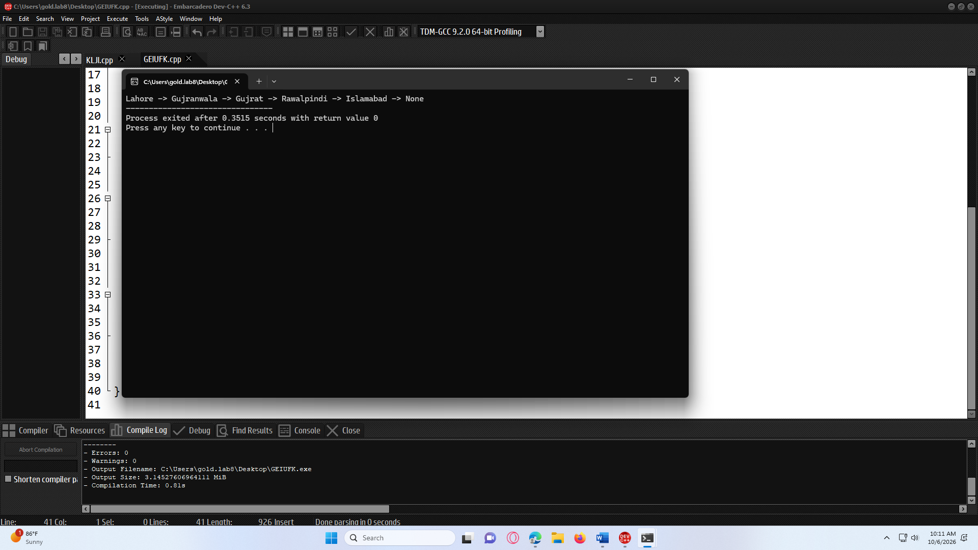
QUESTION:03
Combined Task
CODE:
#include <iostream>
using namespace std;
struct Node {
string orderID;
Node* next;
};
int main() {
Node* head = new Node{"O101", nullptr};
head->next = new Node{"O102", nullptr};
head->next->next = new Node{"O103", nullptr};
head->next->next->next = new Node{"O104", nullptr};
Node* newEnd = new Node{"O105", nullptr};

Node* temp = head;
while (temp->next != nullptr) {
temp = temp->next;
}
temp->next = newEnd;
Node* newMiddle = new Node{"O1025", nullptr};

temp = head;
while (temp != nullptr && temp->orderID != "O102") {
temp = temp->next;
}
if (temp != nullptr) {
newMiddle->next = temp->next;
temp->next = newMiddle;
}
temp = head;
while (temp != nullptr) {
cout << temp->orderID << " -> ";
temp = temp->next;
}
cout << "None";
return 0;
}
OUTPUT:
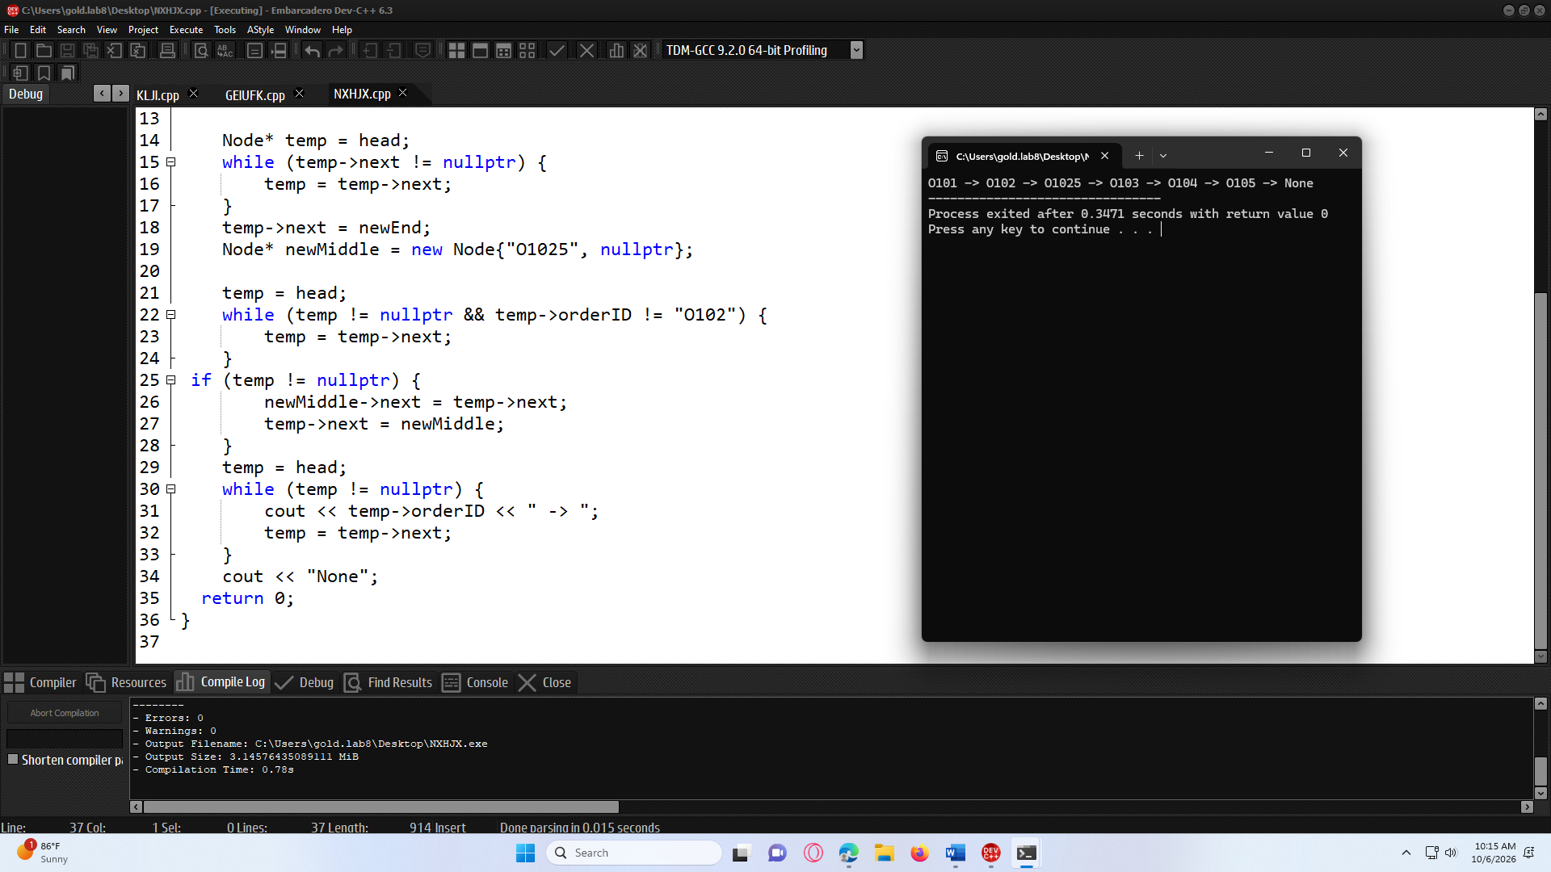

QUESTION:04
Employee List
CODE:
#include <iostream>
using namespace std;
struct Node {
string employeeID;
Node* next;
};
int main() {
Node* head = new Node{"E101", nullptr};
head->next = new Node{"E102", nullptr};
head->next->next = new Node{"E103", nullptr};
head->next->next->next = new Node{"E104", nullptr};
Node* newEnd = new Node{"E105", nullptr};

Node* temp = head;
while (temp->next != nullptr) {
temp = temp->next;
}
temp->next = newEnd;
Node* node1025 = new Node{"E1025", nullptr};
temp = head;
while (temp != nullptr && temp->employeeID != "E102") {
temp = temp->next;
}
if (temp != nullptr) {
node1025->next = temp->next;
temp->next = node1025;
}
Node* node1035 = new Node{"E1035", nullptr};
temp = head;
while (temp != nullptr && temp->employeeID != "E103") {
temp = temp->next;
}
if (temp != nullptr) {
node1035->next = temp->next;
temp->next = node1035;
}
temp = head;
while (temp != nullptr) {
cout << temp->employeeID << " -> ";
temp = temp->next;
}
cout << "None";
return 0;
}

OUTPUT:


